How to install virtual machine and Ubuntu

How to install virtual machine and Ubuntu: VMware and Ubuntu are for PC. If you have a Mac the operating system Linux is in your Mac. You do not need the first section. You need to read the second section to be able to: Enter commands on the terminal, execute a shell scrip file, and execute a C program.

The description for the VMware and Ubuntu is for their older version. Please download the last versions.
If you have VMware Player and Ubuntu installed on your computer, ignore the following sections and go to the next section. In case your old versions cause problems, you can install the new versions by following the steps in section 1.
Note: The instructions and the pictures in this tutorial are from older version of both software. If you decide to install newer versions you may get different pictures.

1. Installing VMware Player and Ubuntu

It is better we enable our file extensions to be able to see the extension of the files in our PC.

1. Click on Start → All Programs → Control Panel and then on Folder Options and on the tab View to see:

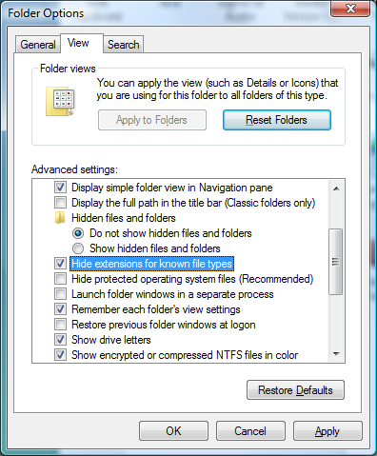

2. Remove the check from the check box labeled Hide extensions from known file types to see:

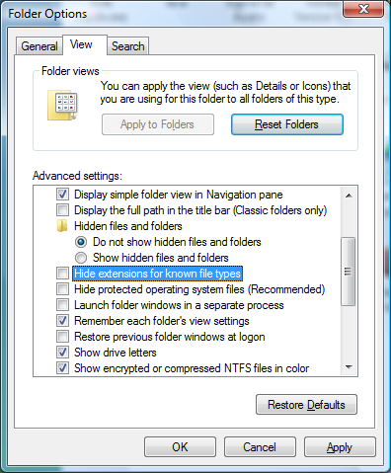

3. Click on the Apply button and close the windows.

There are two major ways to have multiple operating systems (OS) on our computer (laptop or desktop):
a) Dividing the hard drive into partitions and install each operating systems such as XP, Vista, Win 7, and Linux in each partition. With this approach when you like to move from one OS to another you have to reboot the system to load the desired OS. This is a time consuming process and I do not recommend it.

b) Installing software named “VMware Player” to create virtual machines and install each OS in a virtual machine. I suggest this approach. You do not have to reboot the system to move to a different OS.

Make a new folder named Temp in your C drive. You are going to download two exe files into this folder.

1.1. Installing VMware player

1. Download and install VMware Player from the following website into the folder Temp:
https://my.vmware.com/web/vmware/free#desktop_end_user_computing/vmware_player/6_0|PLAYER-600-A|product_downloads

The name of the file is: VMware-player-6.0.0-1295980.exe.

Note: If you prefer to install a higher version please do so.

1. 2. Installing Ubuntu

1. Download Ubuntu from the following website and store it in C:\Temp.

http://www.ubuntu.com/download/ubuntu/download

To see:

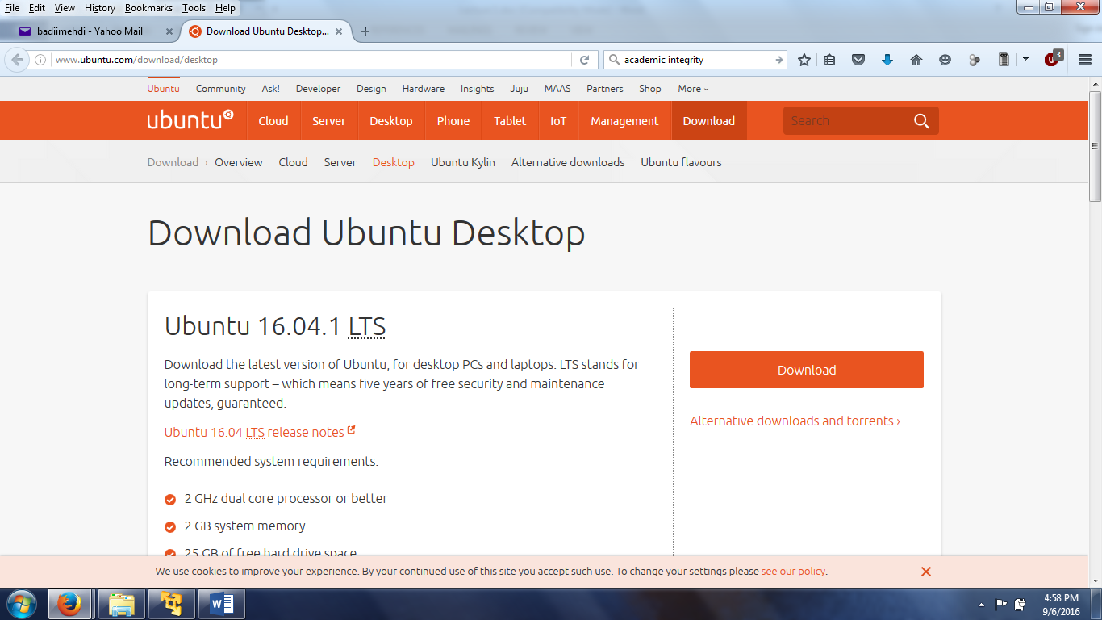

2. Click on: download to see:

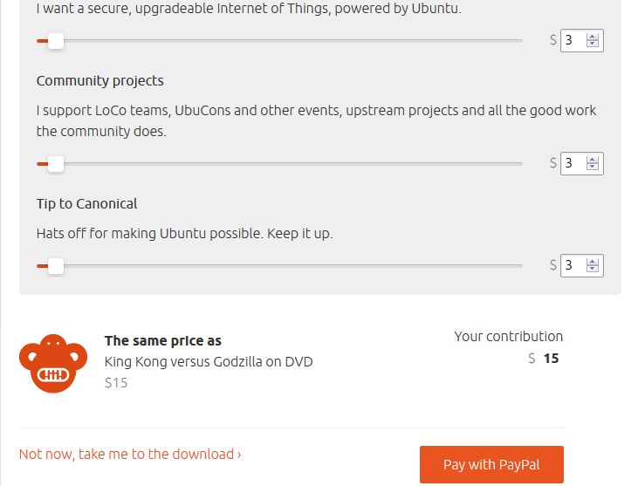

If you do not want to pay click on: Not now, take me to the download. You should see:

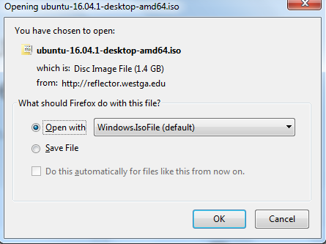

2. Double-click on the short-cut VMware on the desktop to get:

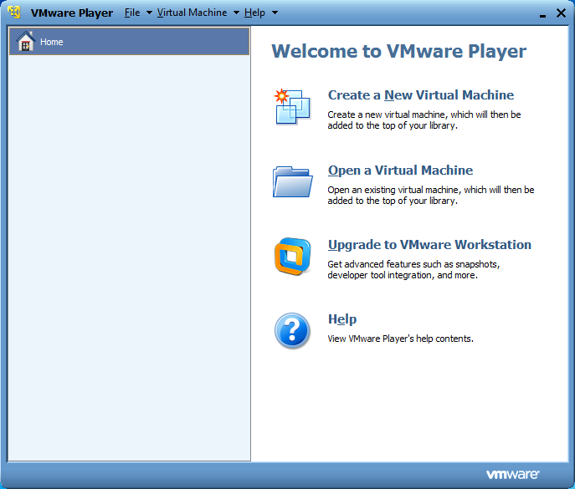

3. Click on the icon labeled: Create a New Virtual Machine and find the file:
ubuntu-16.04.1-desktop-amd64.iso in C:\Temp to see:

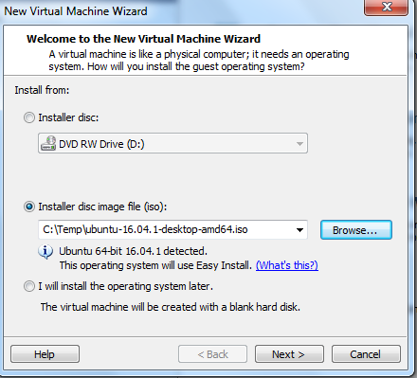

4. Click on ” Next” to see:

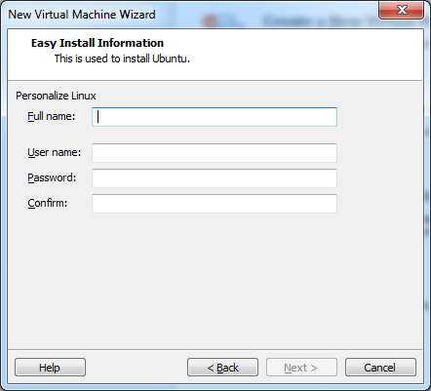

5. Enter a full name, a user name (I (eneterd) entered my first name: mehdi) and a password (I entered: 1234):

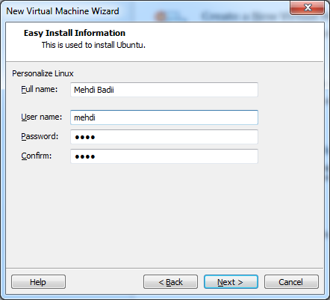

6. Just click on: Next several times and then on: Finish (accept all the defaults). Wait for a few minutes. If you get the following window, open the CD-ROM door and close it and click on: Yes.

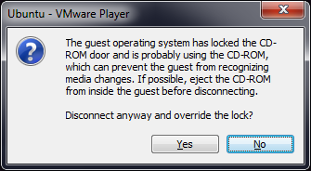

7. Finally you should see:

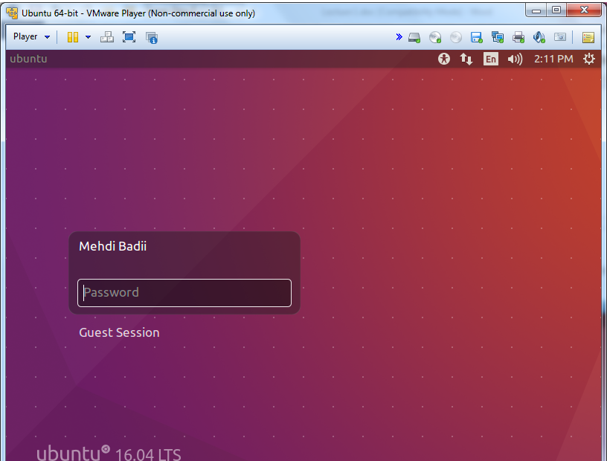

8. Enter your password and hit the enter key too see:

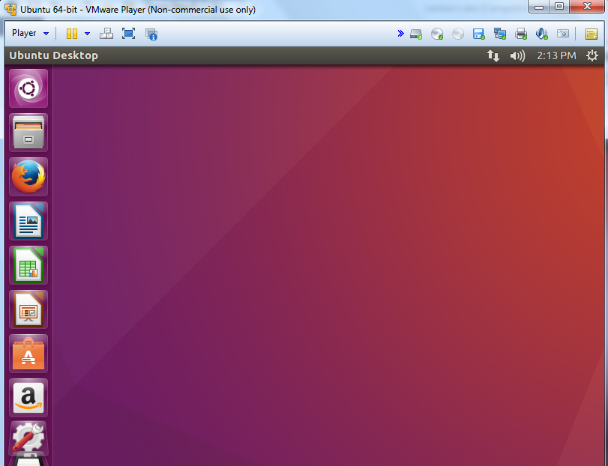

Point to icons to read about them.

2. Using Ubuntu

In this section we learn about the Terminal’s window, an editor, and compile and run a C and a shell program.

1. Double-click on the icon “Dash Home”:  to see a similar screen like:

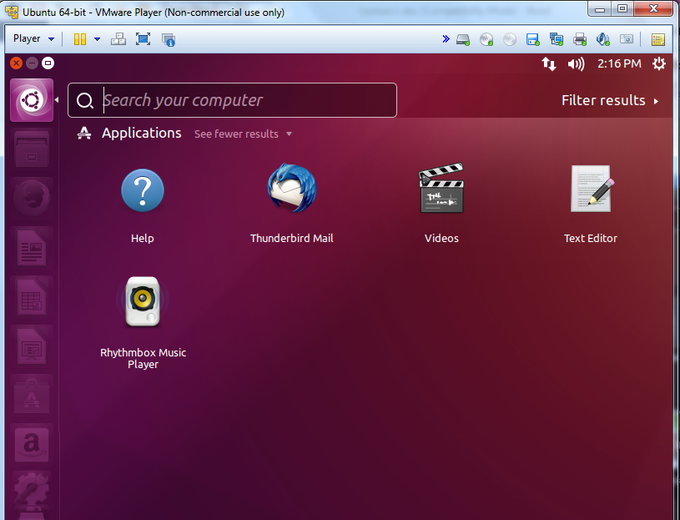

2. In the Search window enter: terminal to see:

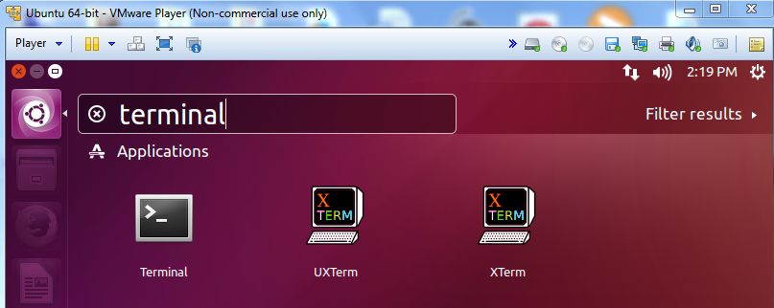

3. There are three terminals. Select one of them (I selected the icon labled: Terminal. That is: 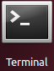) to see:

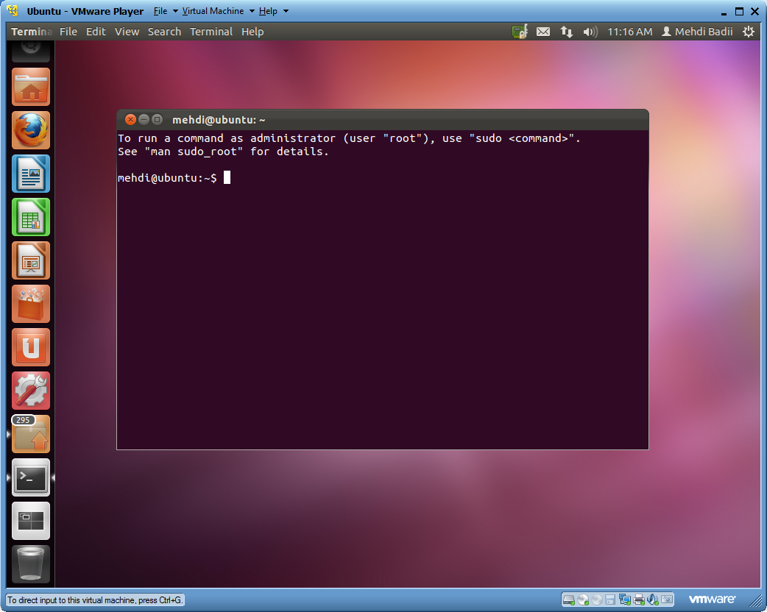

4. To have an easier access to this wimdow, click on its icon (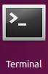) to see:

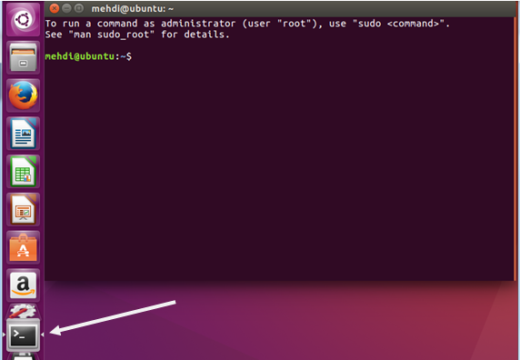

To keep this icon rigth-click on it to see:

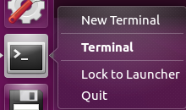

Click on: Lock to Launcher. Close the terminal window. Note that the terminal icon remins on the margine.

5. Click on the : . Enter: gedit in the search window to see:

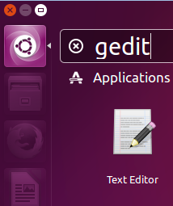

6. Click on this icon to load the editor:

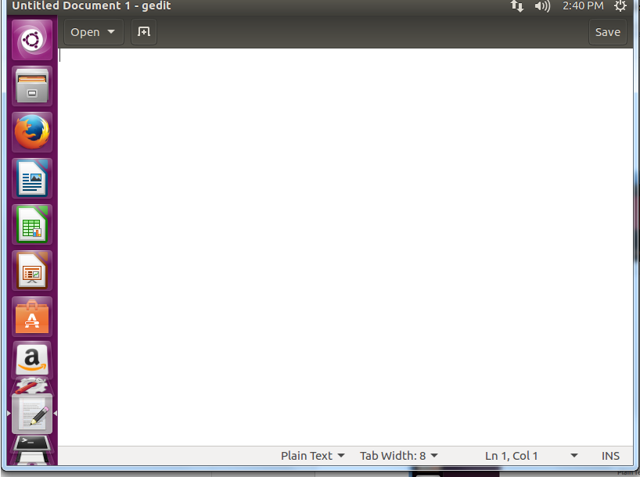

7. Similar to step 4 right-click on its icon () on the left margine. A small window pops up. Select: Lock to luncher. If you close the editor’s window its icon remains on the left margine. By clicking on this icon you can load it again. Close the editor. You can righ-click on any icon on the margine and select: Unlock from luncher to remove some of the icons you do not need. For example this is what I have:

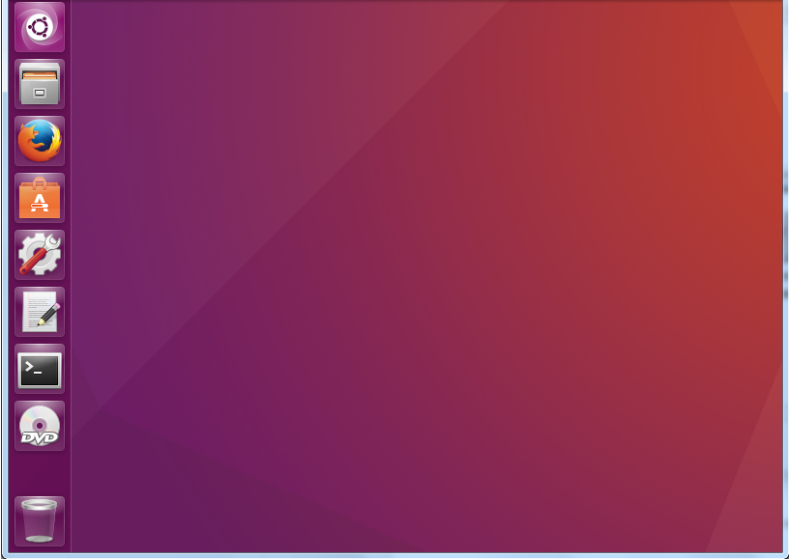

Now we like to make a folder on the desktop named: All and make two folders named: MyShell and MyC to use them for shell and C programs.
8. To access file click on:  to see:

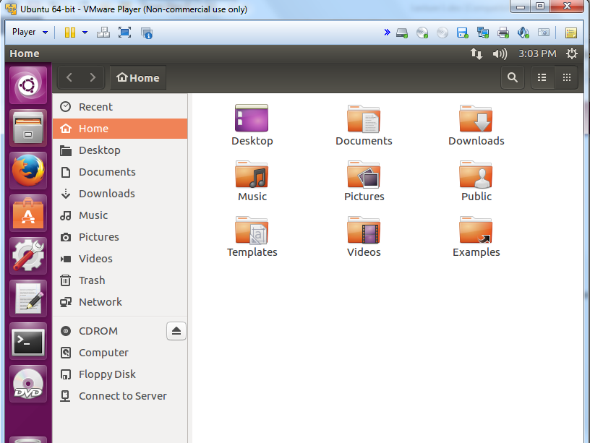

10. Right-click on a blank area to see:

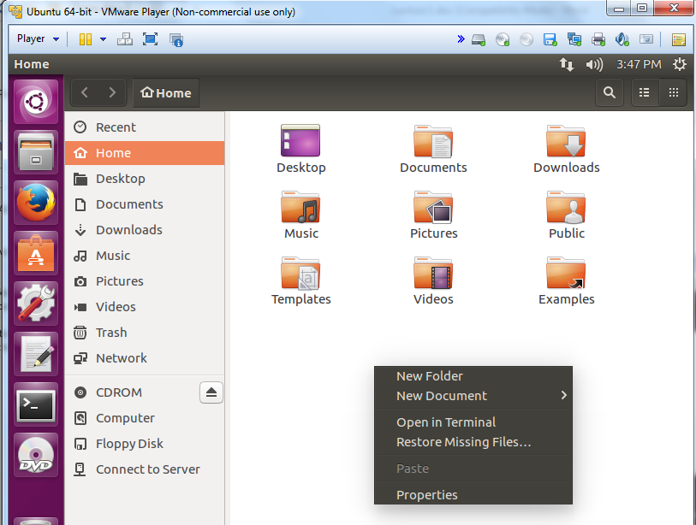

11. Select: New Folder and name the new folder: All to see:

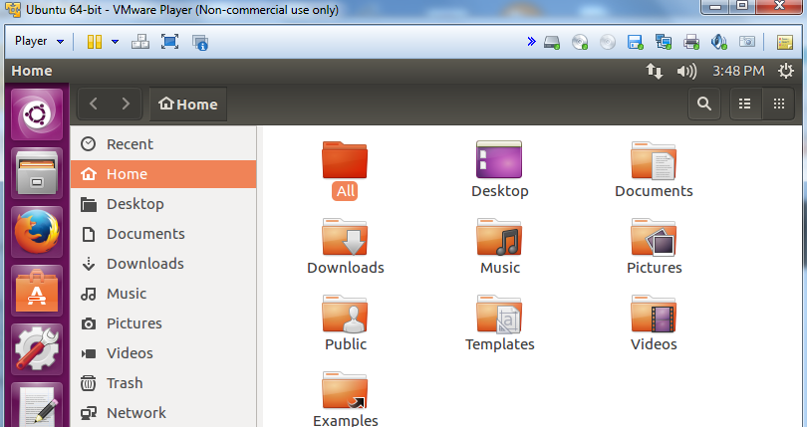

12. Double click on the folder: All to open it and make folders: MyShell and MyC.

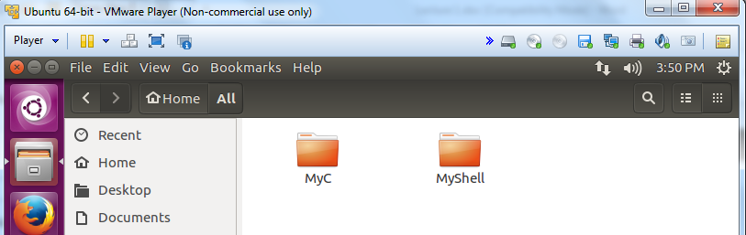

Close the window.

13. Click on the gedit’s icon on the left margine to load the editor. Enter the following:

#include <stdio.h>

int main(){
printf("Hello World\n");
}

11. Save the editor to the file in the folder: MyC with the name: b.c as a C program.

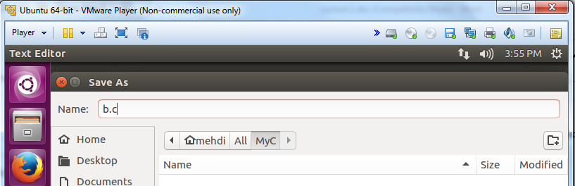

12. Close the editor and load the terminal:

13: Enter: dir to see a similar screen like:

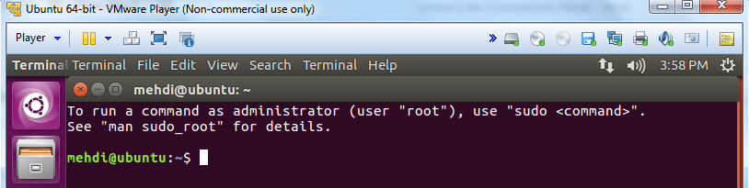

14. Enter: cd All to move to this folder (directory). Enter: dir to see:

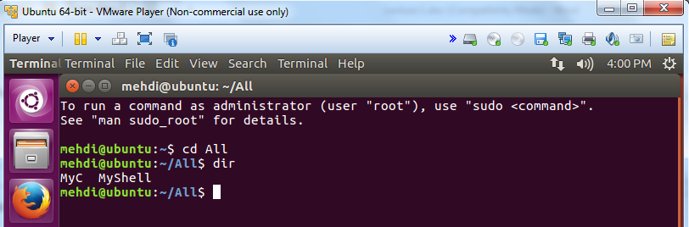

15. Enter: cd MyC to go to this foder. Enter: gcc b.c to compile this C program.
Note: If you see a compile time error, load this file into the editor and correct your error.

16. Enter: dir to see:

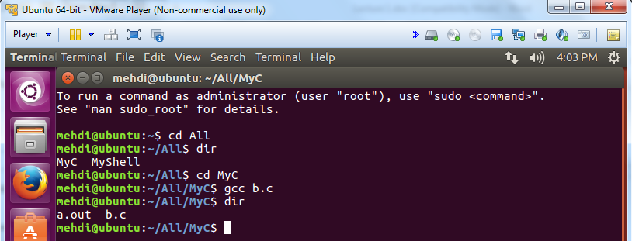

As you see a new file named: a.out is created. This is the program in its executable format. Enter:
./a.out

Note: Do not forget to enter the period.
Note: The default name for the executable (machine code) of a C program is always: a.out.

The output of the program is: Hello World

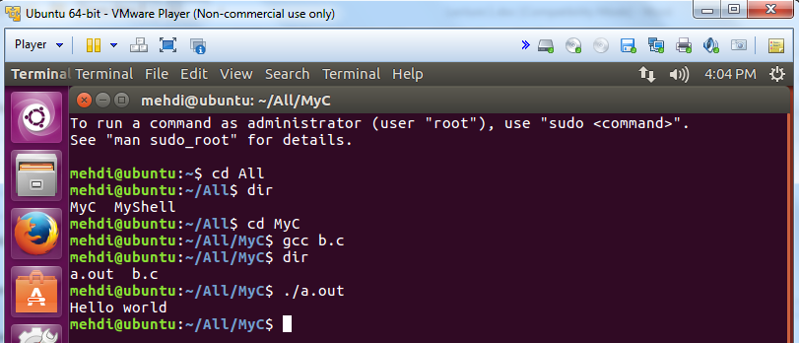

Note: If you have a file in your windows and like to transfer its content to Ubuntu open the vi editor. Copy from the content in your windows and paste it to the vi editor.

17. On the upper right corner click on the icon: and Shut Down Ubuntu.

